**U.S. Department of Energy (DOE)  
Clean Energy to Communities (C2C) Program**

Summary of Technical Assistance (TA) Support

|  |
| --- |
| Marker with solid fill |
| Icon  Description automatically generatedBuildings |
| Icon  Description automatically generatedClean Power |
| Climate Mitigation and Resilience |
| Cross-Sectoral Justice |
| A picture containing text, clipart  Description automatically generatedJobs and Economic Development |
| Icon  Description automatically generatedMobility |

**City University of New York, New York**

TA Scope

From April 2023 to January 2024, the National Renewable Energy Laboratory (NREL) provided technical support to the City University of New York Urban Systems Building Performance Lab (CUNY BPL) in the following areas:

* + - * Setting up an Open Studio Server to use for Building Energy Model (BEM) calibration workflow in CUNY’s high performance computing center
      * Estimating the hardware and software resources required for large scale BEM implementation.
      * Developed a workflow to run ComStock models
      * Calibrated two building models with measured data.

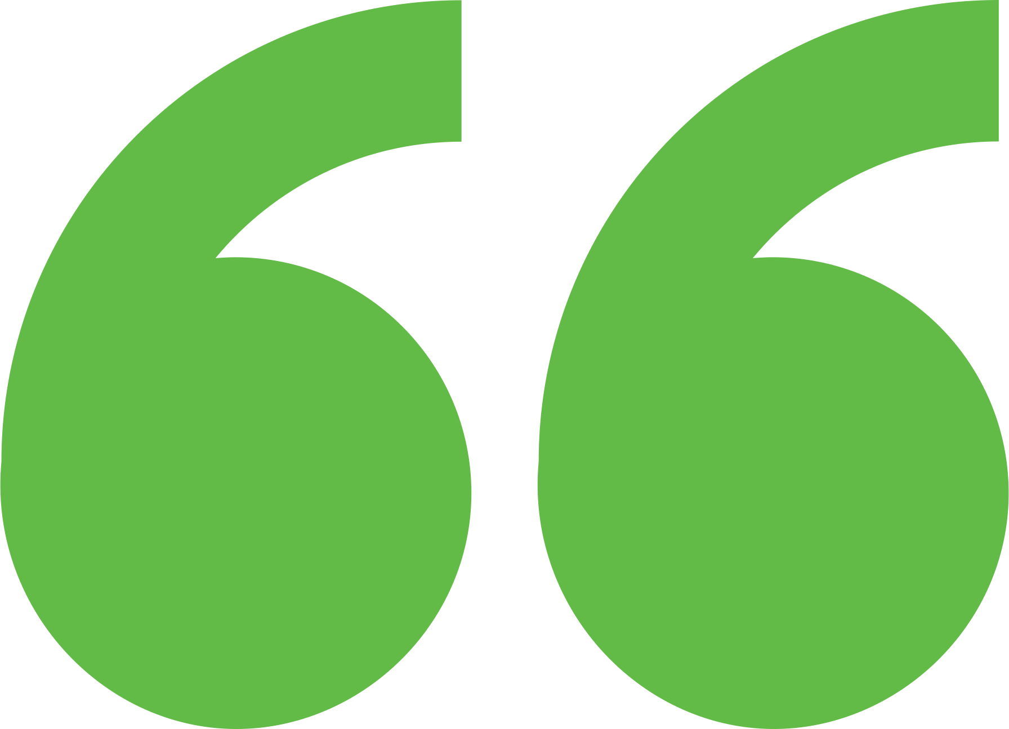 Impact

Helped inform development of the lab’s critical hardware and software to support ongoing building operations research efforts and partnerships.

**Background**

Ann Arbor is a city of approximately 122,000 people located in southeast Michigan. The city and its residents are leaders in sustainability and climate action. Their A2ZERO Climate Action Plan outlines their just transition pathway to community-wide carbon neutrality by 2030. With equity as a focus, they are implementing strategies to improve home energy efficiency (EE) and electrify appliances. Toward this, the city wants to explore community geothermal heating and cooling to serve a variety of building types including rental and affordable housing. The city has applied to DOE’s Geothermal Heating and Cooling Design and Deployment program and garnered the support of City Council to pursue these projects, but they need to understand the concept’s feasibility in order to make a “go, no-go” decision.

**Background**

The CUNY BPL focuses on improving efficiency and optimizing building operations through continuing education programs for facility managers, building operators, and energy professionals, internships for CUNY students, and building systems research and development.

Expert Match Team

**Alexandra Kramer**  
Community Lead, Main Expert Match Point of Contact, National Renewable Energy Laboratory (NREL)

**Eric Bonnema**  
Researcher, Mechanical Engineer, NREL

Community Team

**Duncan Prahl**  
City University of New York Building Performance Lab (CUNY BPL) Project Lead

**Amanda O’Donnel**  
CUNY BPL Project Lead

**Mike Burton**  
CUNY BPL Project Lead

**Farshad Kheiri**  
CUNY BPL Project Lead

For more information, visit:  
**energy.gov/eere/clean-energy-communities-program**

August 2024